Contents

PERSONAL APPLICATION 2

HOW TO MAKE A PERSONAL APPLICATION 2

UPDATE THE PERSONAL INFORMATION 2

INTRODUCTION TO THE TOP BAR BUTTONS FROM TOP RIGHT TO LEFT 3

CREATE A PERSONAL APPLICATION 4

SIGN THE DOCUMENT 5

UPLOAD AN ANNEXURE 6

SENDING THE PERSONAL APPLICATION 7

SETTING PRIORITY OF THE APPLICATION 8

ADDING DEPARTMENT TO FAVOURITE LIST 9

CREATING PARTCASE 9

SPLIT VIEW FOR ENCLOSURE AND NOTE ON FILE 11

ACTIONS ON NOTE ON FILE SECTION ENCLOSURE SECTION 12

SENDING A FILE 13

ACTIONS A CORD USER CAN TAKE 16

HOW TO ADD A COVER NOTE IN A PERSONAL APPLICATION 17

NOTE ON FILE SECTION 18

ENCLOSURE SECTION- 19

SIGN 19

ADD COVER LETTER 20

FLAGGING THE DOCUMENT 22

SENDING TO NEXT LEVEL 23

STATUS OF THE APPLICATION 26

MERGING THE PARTCASE 27

STEPS TO MENTION DECISION ON THE PARTCASE FILE 28

STEPS TO ADD PARTCASE BY THE USER 29

# PERSONAL APPLICATION

# HOW TO MAKE A PERSONAL APPLICATION

* Log In to E-office Page
* The page will appear as below:

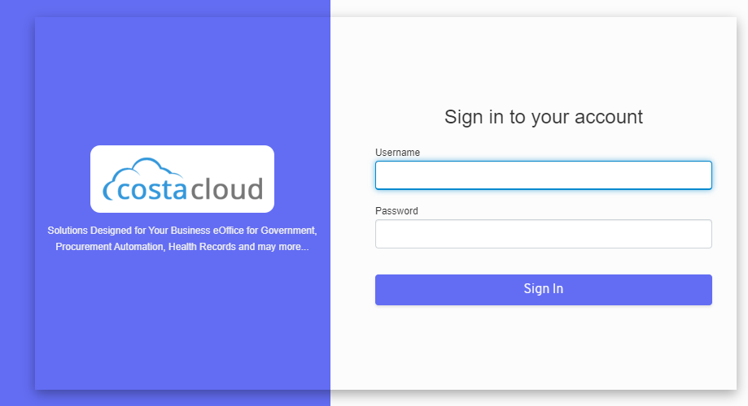

* Enter the Username and Password
* Then click on the Sign In button

# UPDATE THE PERSONAL INFORMATION

* Update the personal information from the **MY INFO** button on the top right of the pages shown below

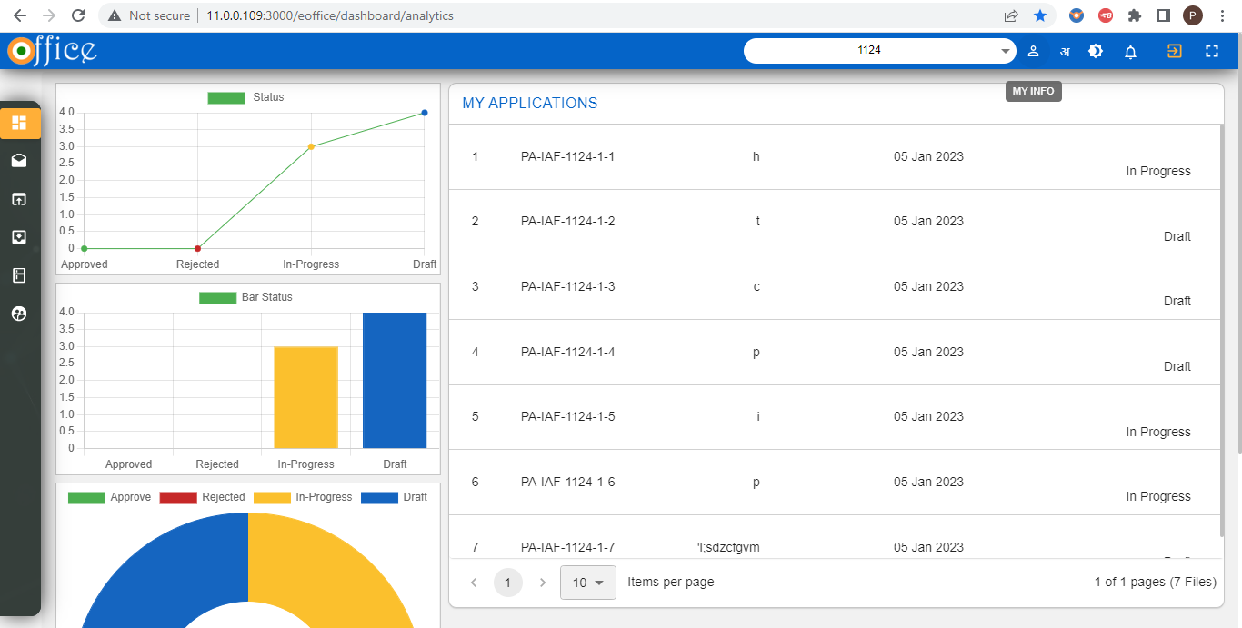

* After clicking following fields will appear to where user have to fill their personal information and click on the Update button.

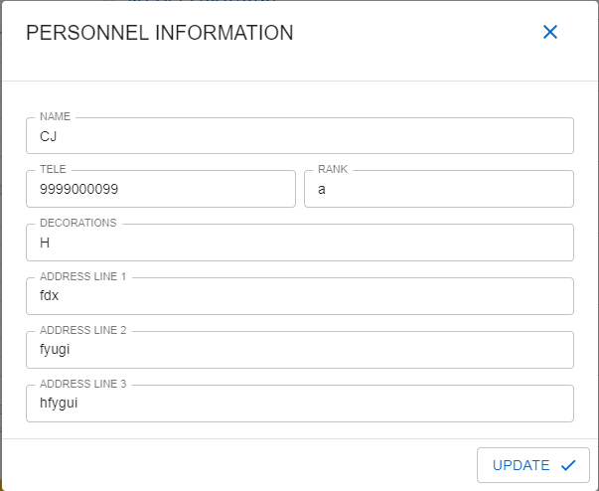

# INTRODUCTION TO THE TOP BAR BUTTONS FROM TOP RIGHT TO LEFT

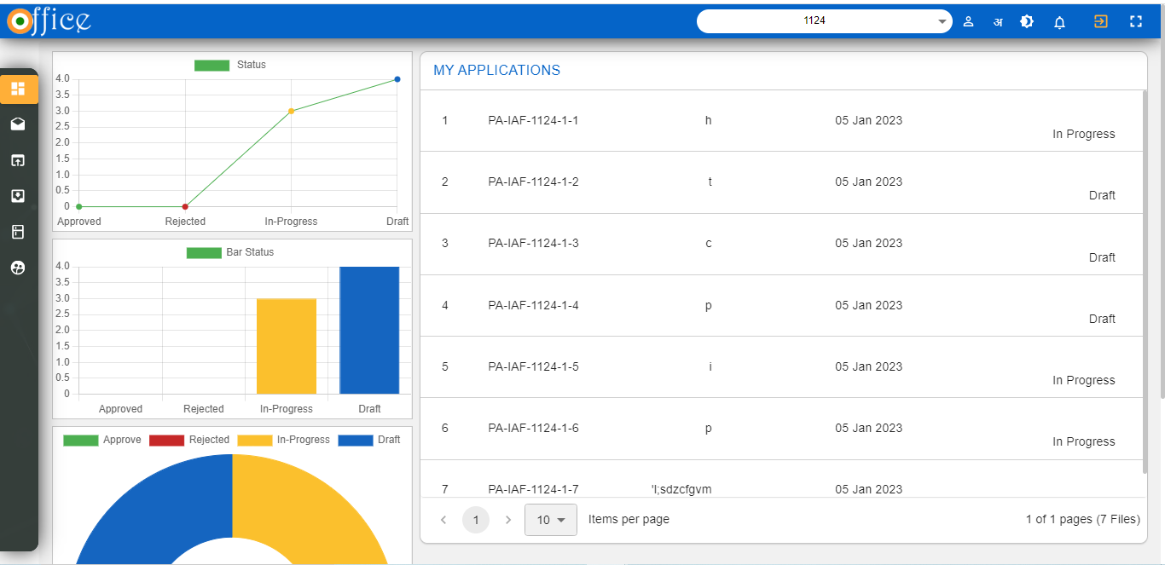

* **MAXIMIZE & MINIMIZE BUTTON**: this button will be used to adjust the working screen of the Application according to the user comfort.
* **LOGOUT BUTTON:** This button will make the user to log out from the current Application.
* **NOTIFICATION BUTTON:** This button will show the latest notification received with the count.
* **WORK MODE BUTTON:** By using this button user can swith between the work modes according to his eye comfort.
* **LANGUAGE BUTTON**: By using this button user can switch between the **HINDI** and **ENGLISH** Language.
* **UPDATE USER INFO BUTTON**: This button is used to update the user information into the system.

# CREATE A PERSONAL APPLICATION

* After updating the personal information then the user have to click on the **PA** menu on the side navigation panel to create a Personal Application.

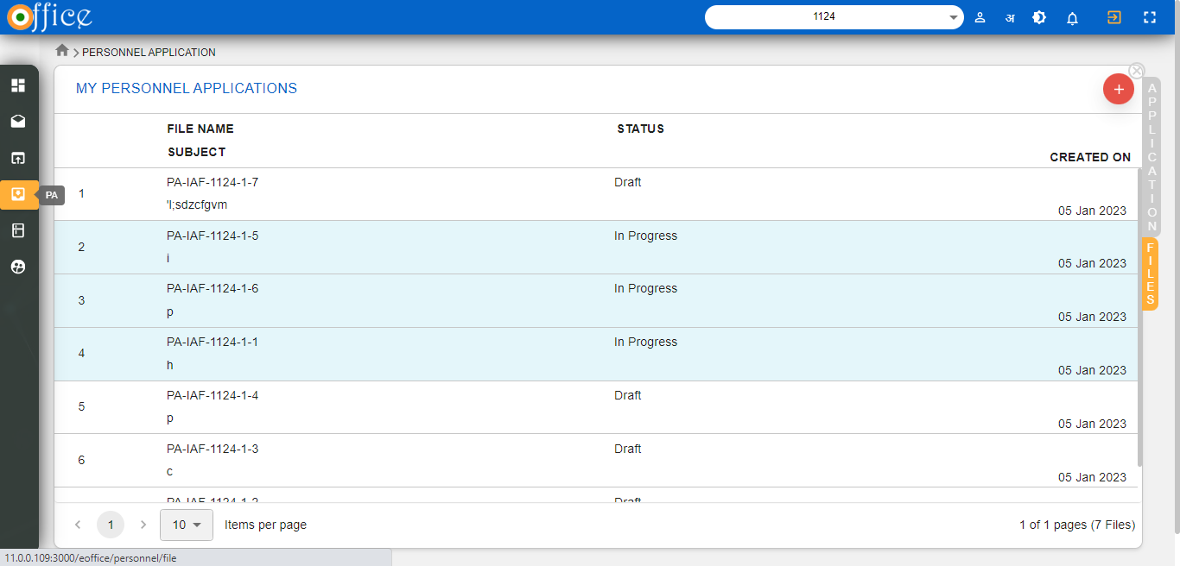

* After clicking on PA button following page will open with side button which is Enabled i.e Files .
* Then click on the (+) button which will open popup menu as shown below .
* Here user have to Create a personal file by Filling the subject and click on the submit button

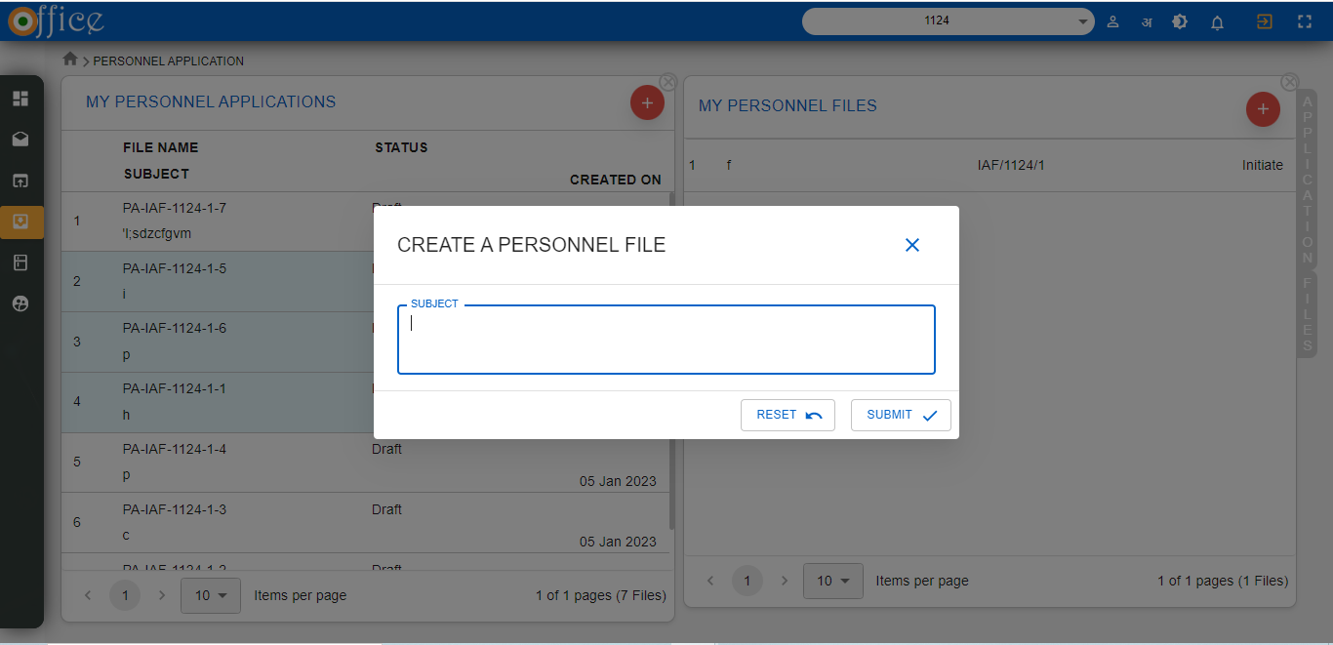

* After creating the personal file user has to create a Personal application by clicking on the (+) icon in the **MY PERSONAL APPLICATION** sections shown below.
* After clicking another popup will open where user has to Create a Personal Application by filling the Subject and select the personal file .
* The user can also create a personal file by clicking on the (+) button on the **Create Personal** **Application** popup.

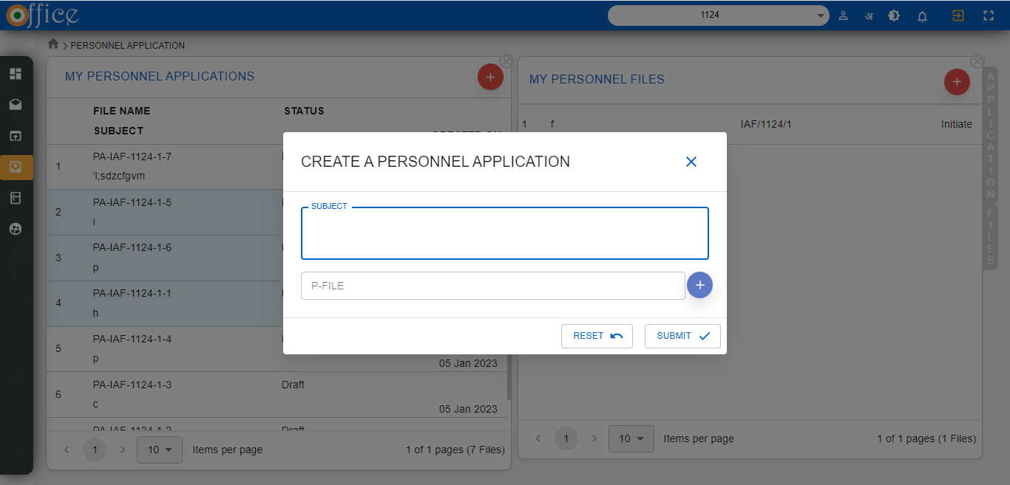

# SIGN THE DOCUMENT

* After clicking on the Submit button a following page will open as shown below .

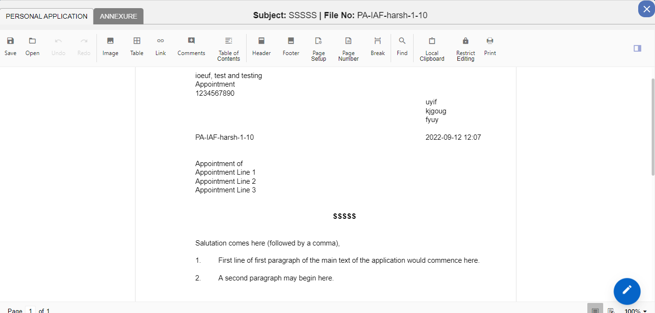

* Here user can SIGN the PA and also he can add comments to the PA.
* After clicking on the **SIGN** button following Popup window will appear where user can add signature by clicking on the **SIGN** button.

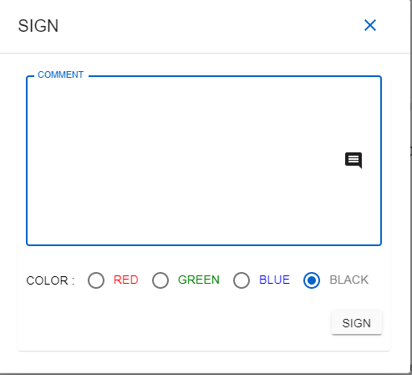

# UPLOAD AN ANNEXURE

* Here user can sign the personal application and also add annexure to the personal application by clicking on the Annexure Tab.
* After clicking on the annexure tab following page will open as shown below

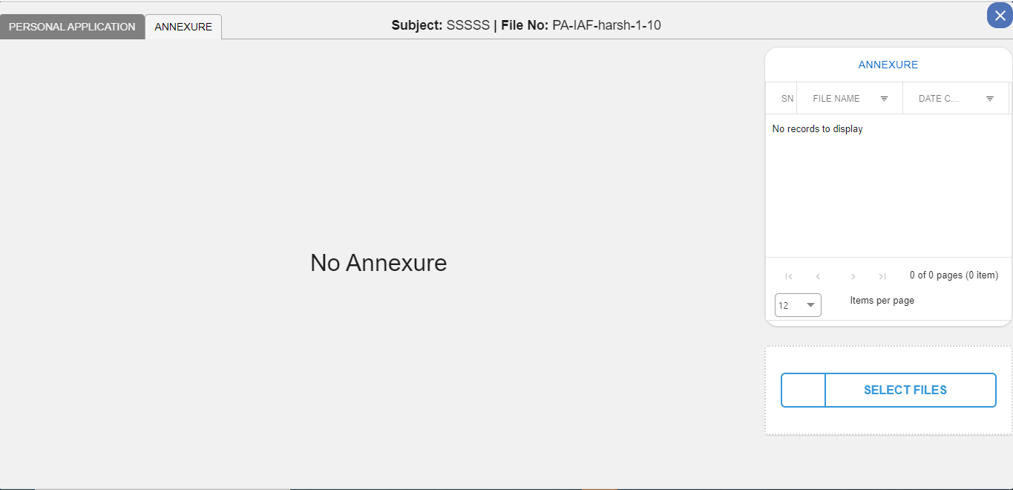

* The user can upload annexure in the annexure section by clicking on the Select File Button as indicated above.
* After clicking on the select files tab a popup will appear from where user he has to select the document which he wants to upload.
* Here user can SIGN the the annexure also by clicking on the SIGN button in the Annexure section.
* After signing the document he also has a option to UNDO his activity by clicking on the UNDO button as shown in the image below.

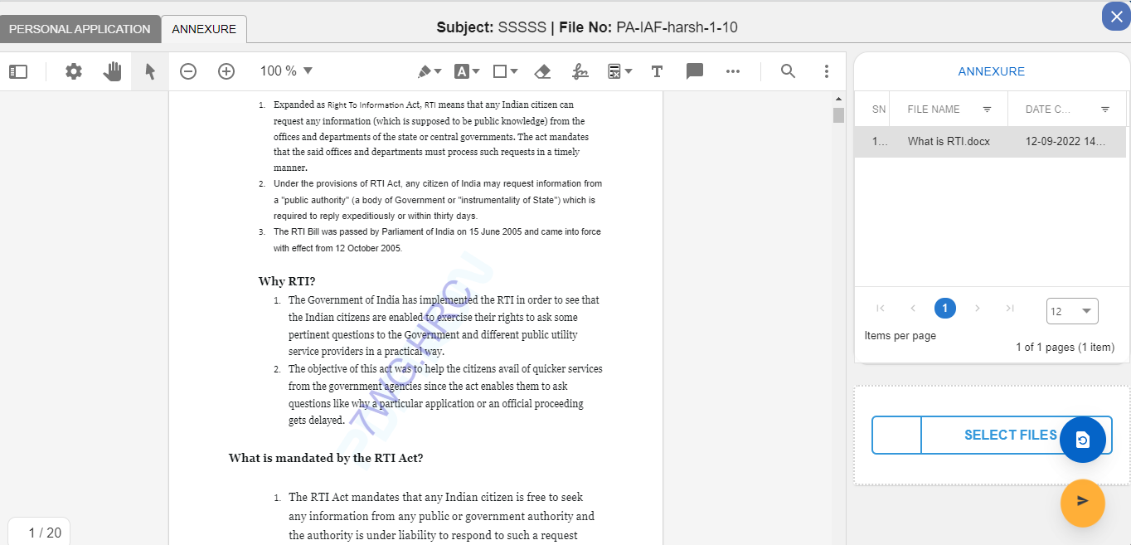

* Here user will have to remember that after signing it on both the documents only he can send the file to the next level.

# SENDING THE PERSONAL APPLICATION

* After signing on the both the documents the user will now click on the SEND button to send the file to the another department.
* To send the file user will click on the send button as shown in the image below.



* After clicking on the send button the following popup window will open from which user can forward his application to the next department.

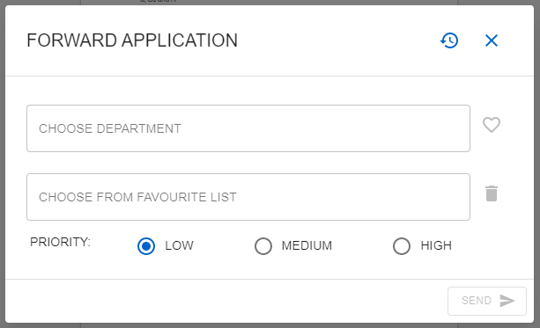

# SETTING PRIORITY OF THE APPLICATION

By using this feature user can set priority of the Application marked as

* LOW
* Medium
* High

According to the severity of the Application.

# ADDING DEPARTMENT TO FAVOURITE LIST

* From here user can choose his desired department to which he has to send the application by choosing the department from the dropdown by entering at least three character of the department name then related department list will appear in dropdown to select.
* Also he can add the department to his favourite list by clicking it on add to **Favourite List** button**.**
* After Selecting the departments, click on the **SEND** button to send the file to the another department.

# CREATING PARTCASE

* When the designated user will receive the application in his **inbox** then he will Double click on the file name .

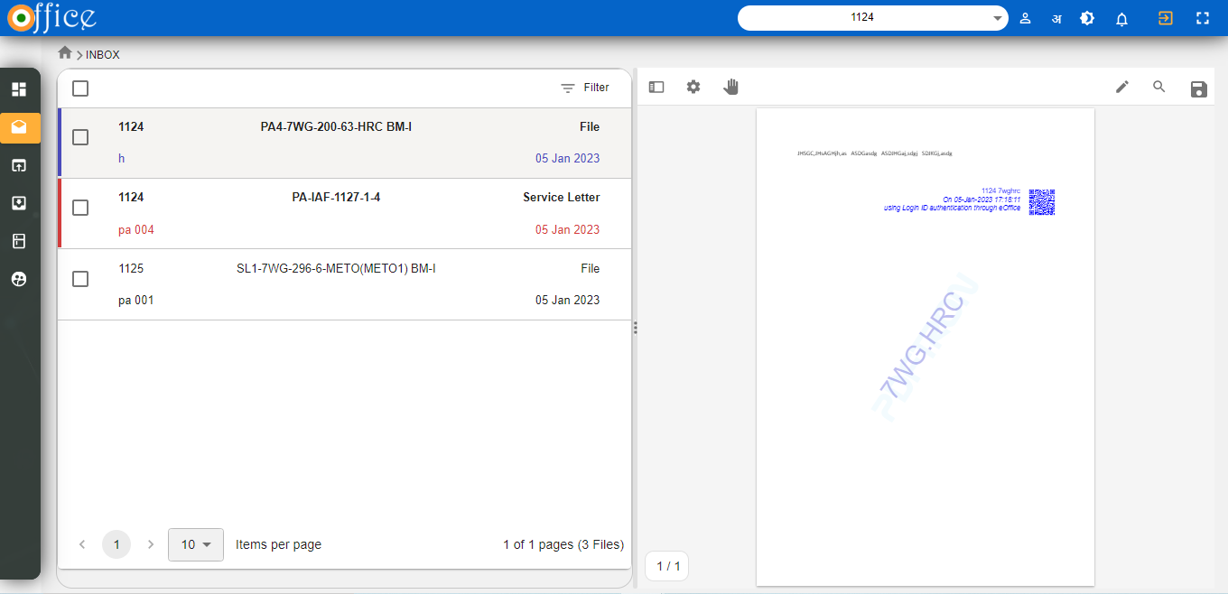

* Then the file will open with the preview menu as below with the Priority as a side bar of the Personal Application.

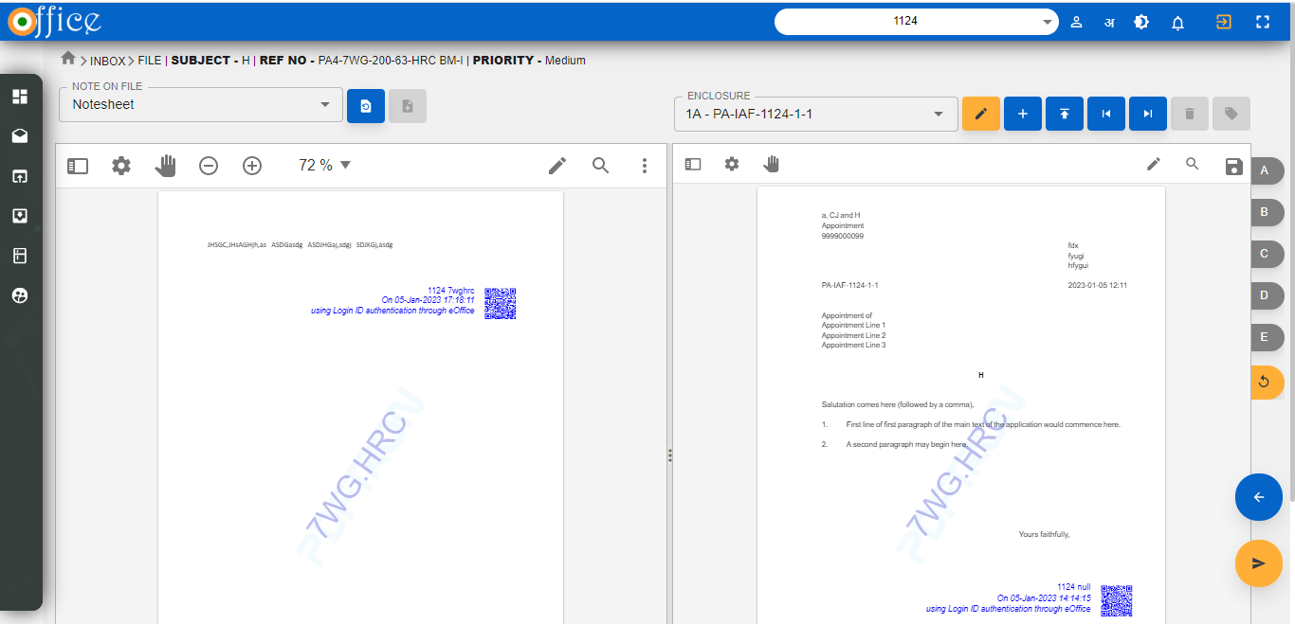

* Then the designated user will select file **FOR NOF** adding to the personal application by clicking on the **SELECT FILE FOR NOF** button as in the figure below.
* 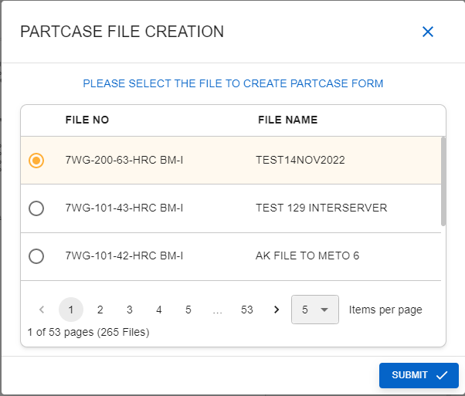
* After clicking on the **SELECT FILE FOR NOF** the following window will open where user can add file to create a **PARTCASE FILE** and then click on **SUBMIT** button tofill his response**.**
* User will select the file which is relevant to the application to create **a PARTCASE FORM.**
* After that the **CREATE PARTCASE FILE** button will be **ENABLED** as shown in the image below.

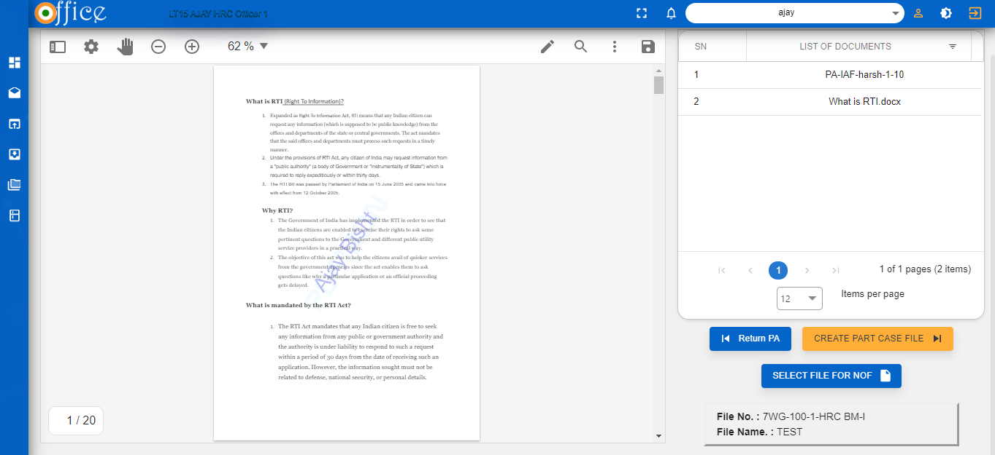

* After clicking on the button a following popup window will open for confirming to create a Part case file as in the figure below.

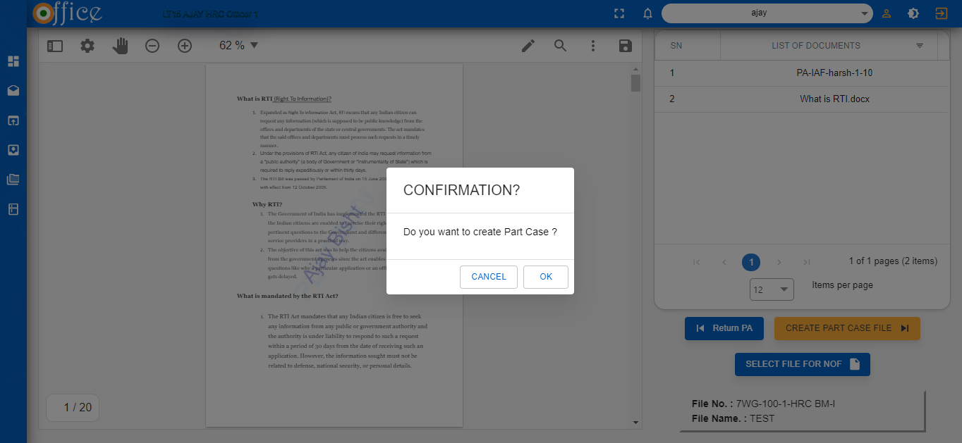

* After clicking On OK button then the user will be directed to the following window as shown below for adding NOTING and ENCLOSURE to the file.

# SPLIT VIEW FOR ENCLOSURE AND NOTE ON FILE

The following Split view will open with one module on Note on File module and other with enclosure module.

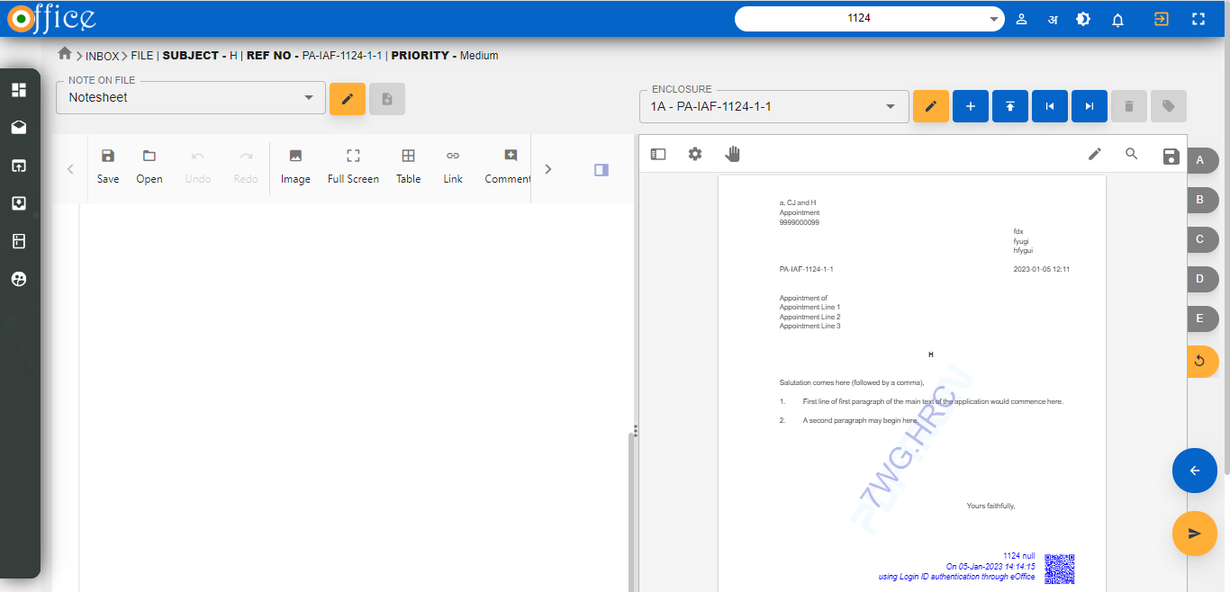

In this module user can perform activities like:-

1. Adding a note sheet with his response.
2. Signing the note sheet.
3. Adding Flag to the important documents.
4. Upload a Enclosure.
5. Signing the Enclosure.

# ACTIONS ON NOTE ON FILE SECTION ENCLOSURE SECTION



* If the user has to add any Note on the file, then he will click on the blank page to add **NOTE** on the file as shown in the image above.
* To mark the Important pages in the document for the reference of the next user, a user can mark a **TAG** for the file as As highlighted in the image below in the Enclosure Section.



# SENDING A FILE

* Then the user will click on the **SEND** button as indicated in the image below



* After clicking on the SEND button following window will open

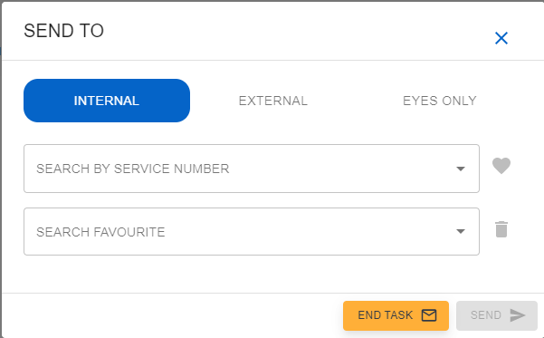

* In this window there are three buttons on which user can click.
  + **INTERNAL**-If user clicks on internal button, then he can send the file internally within the DEPARMENT. He can search the user by his service number.
  + **EXTERNAL**- If user click on External button, then he can send the file to the other DEPARMENT. He can search the user by his section.
  + **EYES ONLY**-If user clicks on the eyes only then he can send the file to the **SPECIFIC** user.

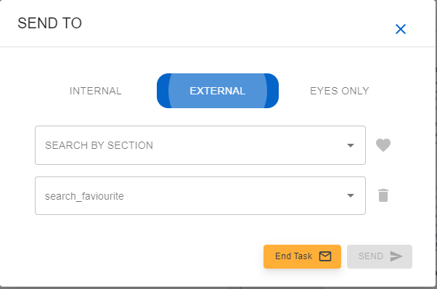

* For sending the file Externally user can search by section.

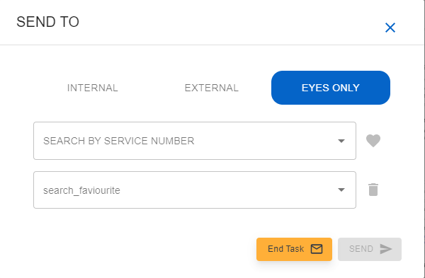

* If the user selects EYES only option then he can search the user by specific service number.
* if the user finds all the documents satisfactory then he will click on the END TASK button as shown below



# ACTIONS A CORD USER CAN TAKE

* After that following window will appear asking for the confirmation

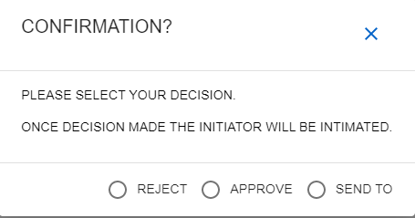

* Once confirmed user will click on following buttons
  + **REJECT** – To reject the file.
  + **APPROVE** -To approve the application.
  + **SEND TO**-send to another user for further confirmation about the application.
* Once confirmed the Application cycle will be completed.

After PartCase has been Created and is being Send to the Next level then User Must have to Insert Cover Note into the Personal Application when he is sending The Personal Application Internally.

# HOW TO ADD A COVER NOTE IN A PERSONAL APPLICATION

* When the user will Receive the PA into the Inbox then the Application will have File type as “FILE”.

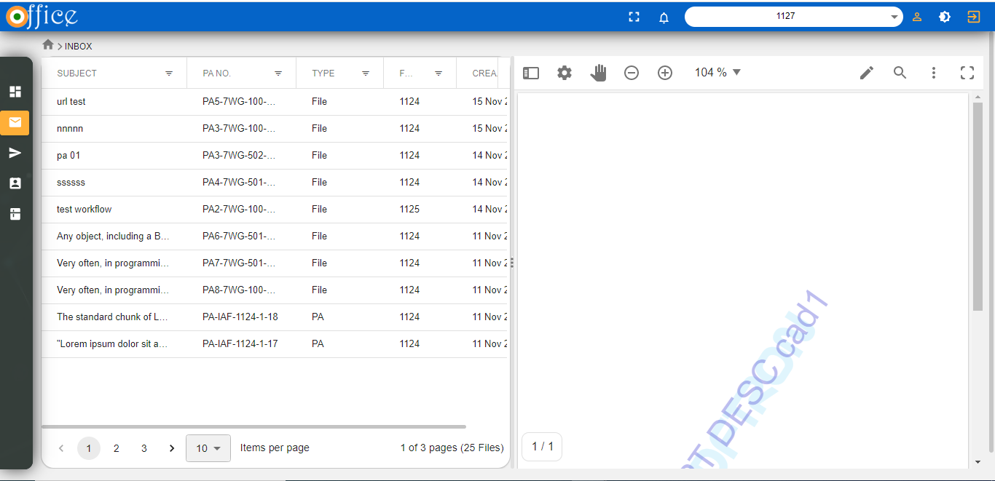

* Then User will click on the Application On which he has to Take any further Action.
* After Clicking on the Application A window will open As shown below For Reference.

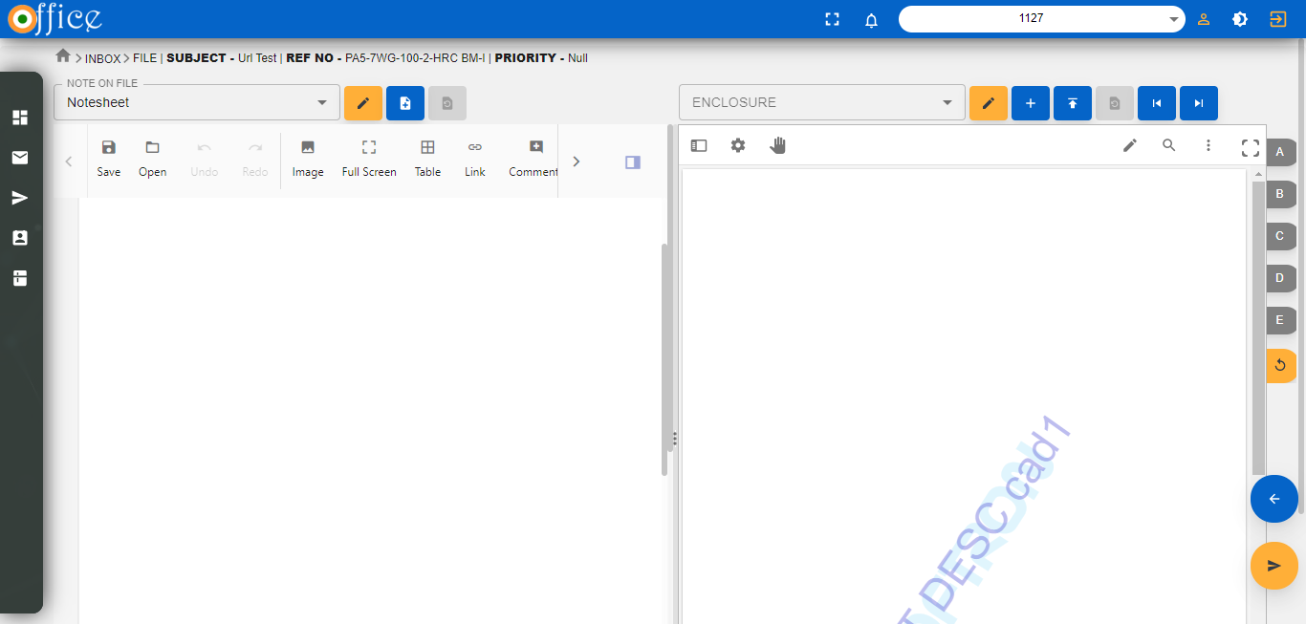

* A split view Window will open after clicking on the Application.
* One Section will be Named as “**Note on File”** while other Section Will be named as **“Enclosure**” Section .

Enclosure Section

Note On File Section

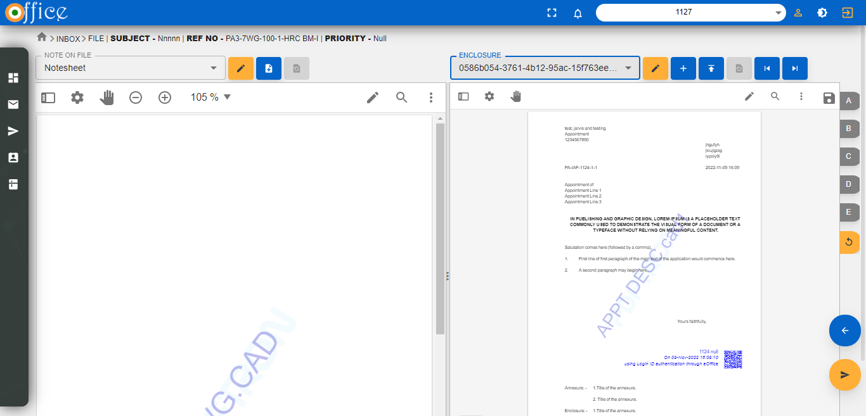

# NOTE ON FILE SECTION

* **In this Section there Are three major buttons Adjacent to the Subject of the Noting File.**
  + **SIGN: - User can sign the noting File.**
  + **ADD NOTE:BY using this button User Can Add A new Noting into the Existing Application.**
  + **UNDO: This Button is used to Undo the SIGN action done by the User.**

ADD Noting Button

SIGN button



# ENCLOSURE SECTION-

* **In this Section there are six Buttons Beside the Enclosure Subject Section**
  + **SIGN:Used to Sign the Document**
  + **ADD COVER LETTER:Used to Add Cover Note to the Current File.**
  + **UPLOAD ENClOSURE :Used to Upload The Enclosure In the Current file.**
  + **UNDO:-Used to Undo the Signature On the Current File.**
  + **FORWARD:-Used to Jump to the next Document**
  + **BACKWARD:-Used to Jump to the Previous Document.**

# SIGN

* **This button is used to Sign the Document User Want to Sign.**
* **When user will click on the SIGN button Following Dialogue BOX Will Open as Below**

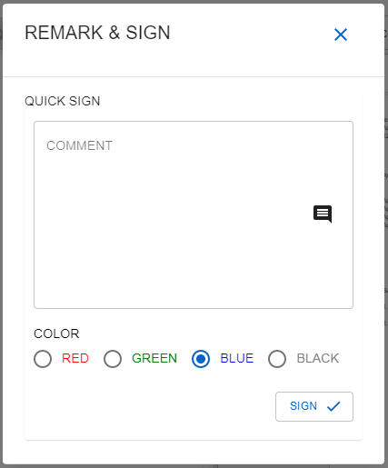

* **Here user can put his comment in the Comment Section**
* **In the colour Section he can choose the Shade in which user want to sign the Document from the options Given.**
* **Then Click on the SIGN button to SIGN the Document.**

# ADD COVER LETTER

* **User can add cover Note to his File by clicking on the (+) button .**
* **When user will click on the Add cover Note button then the following Dialouge box will Appear .**

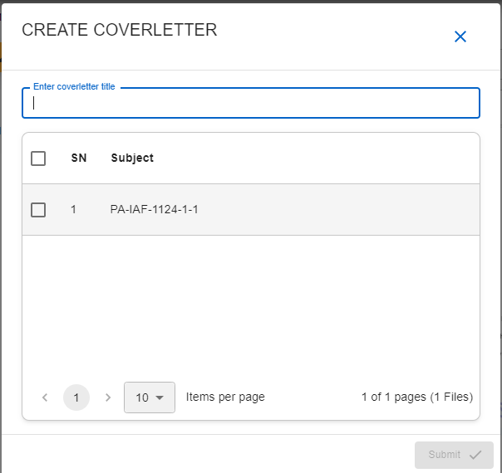

* Here In the **Enter Cover Letter Title** Section User will Enter the Title for the Cover Letter and Select the File from the list of Files in the list Below.

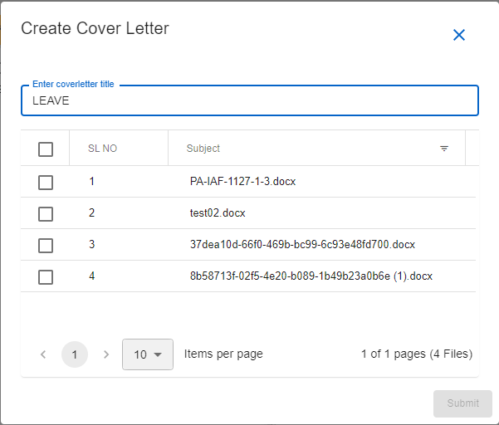

* After Entering the Title and Selecting the File from the list of files the **“SUBMIT”** button will be Enabled as Shown in the image below.

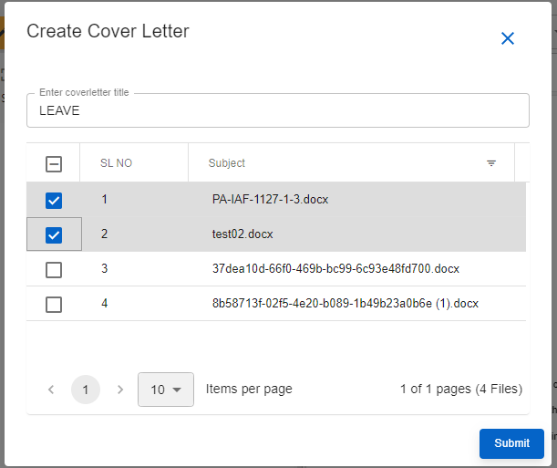

* To add the cover note the user will then click on the **SUBMIT** button to add the note.

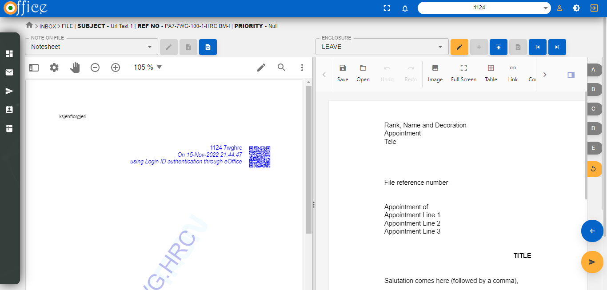

SIGN

* Then the Note with the Updated Subject will be Visible in the Enclosure Subject Section.
* Here user can **SIGN** the Added cover note By clicking on the SIGN button.

**NOTE:** The thing to note here is that only the person of the same Department can only add cover note to the File.

# FLAGGING THE DOCUMENT

* **From the List of Enclosures User can Flag the Document i.e user can mark a document from the enclosures list which he might think is Most Important from his point of view for the Next user.**

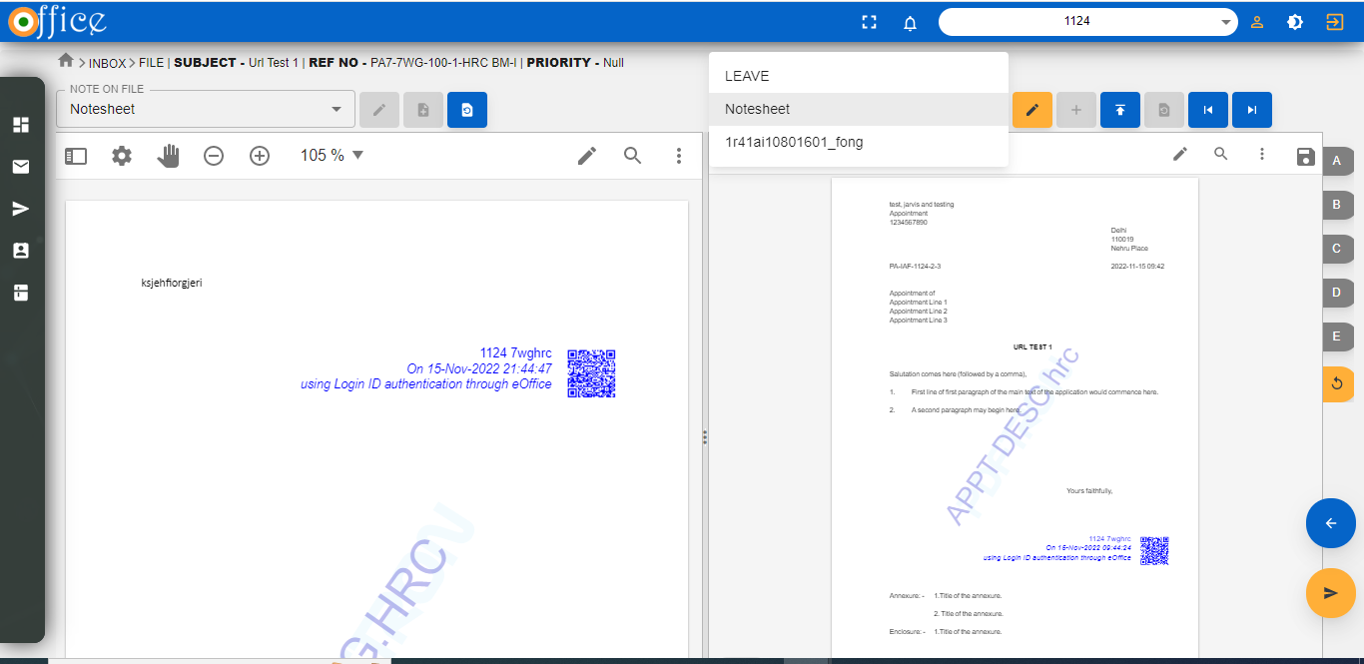

* **User can Flag the Document by clicking on the Flag Icons named as A,B,C,D and E.**
* **After Clicking on the Flag Button The buttons Will be Enabled and Highlighted as shown in the Images Below.**

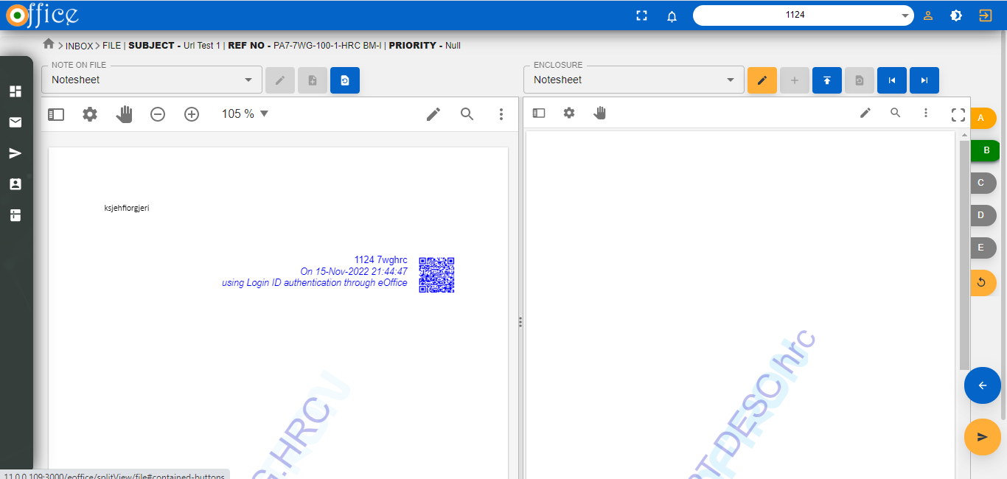

Flagged

* **If user want to reset the Flags then There is A reset button At the Last of flag Icons.**



RESET

# SENDING TO NEXT LEVEL

* When user has Added cover note and Signed all documents then he will be sending this Personal Application to the next Level.
* For this user Will click on the **SEND** button .



SEND

* **After clicking on the Send button the Following Dialogue Box will open as shown in the Image Below.**
* Now the user has to Send the File to the Next Level then he will Choose the **EXTERNAL** Department by clicking on the **EXTERNAL Button in the SEND TO** section.

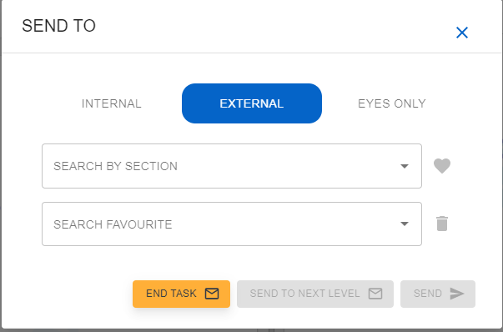

* After user will Enter the three Letters of the Department From which the department List will appear in the dropdown .

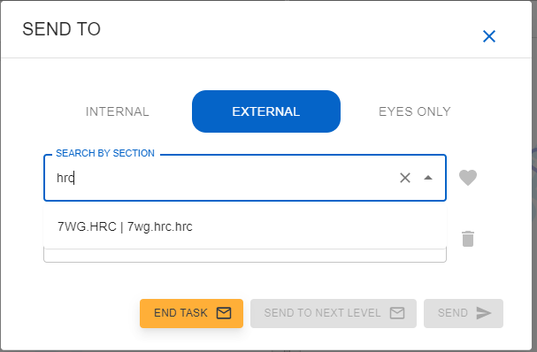

* **From here user can Select the department he want to Send the File.**

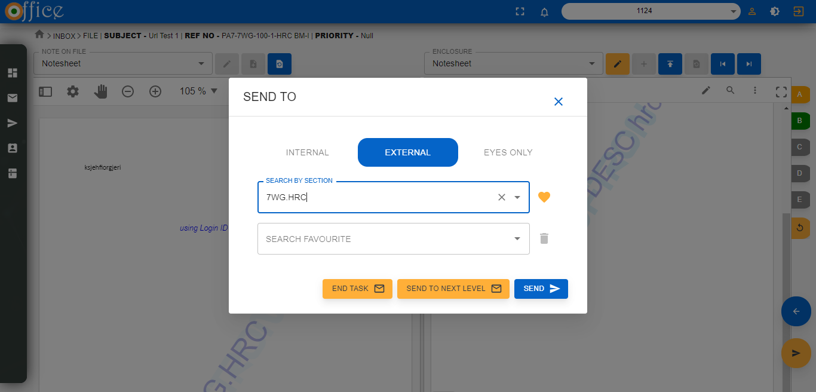

* When user has selected the Department then the Send to Next Level button Will be Enabled as shown in the image above .
* After User will Click on the **“Send to Next Level”** button.
* After Clicking on the **“Send to Next Level”** button following dialogue Box will Appear From which user will Select the Cover Note Whom with which he wants to continue with the Appllication.

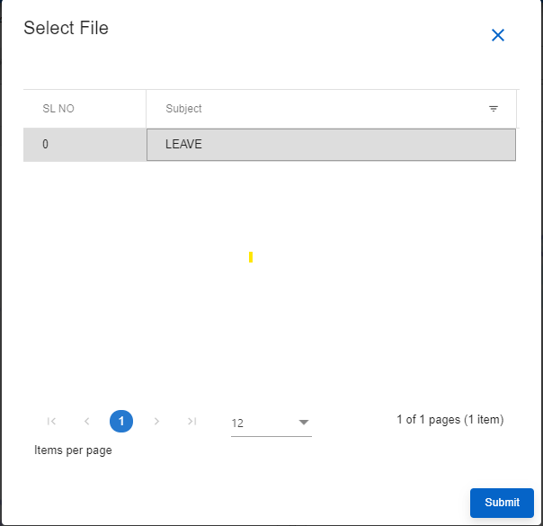

* After Selecting the file User will Click on the **“SUBMIT”** button to proceed with the Application.

# STATUS OF THE APPLICATION

* When the Decision has been made from the Cord User on the File then He will Attach the cover note with his Decision and Remarks.
* After that the File will Go to the Cord user of the department as a **“SERVICE LETTER”** in his inbox.

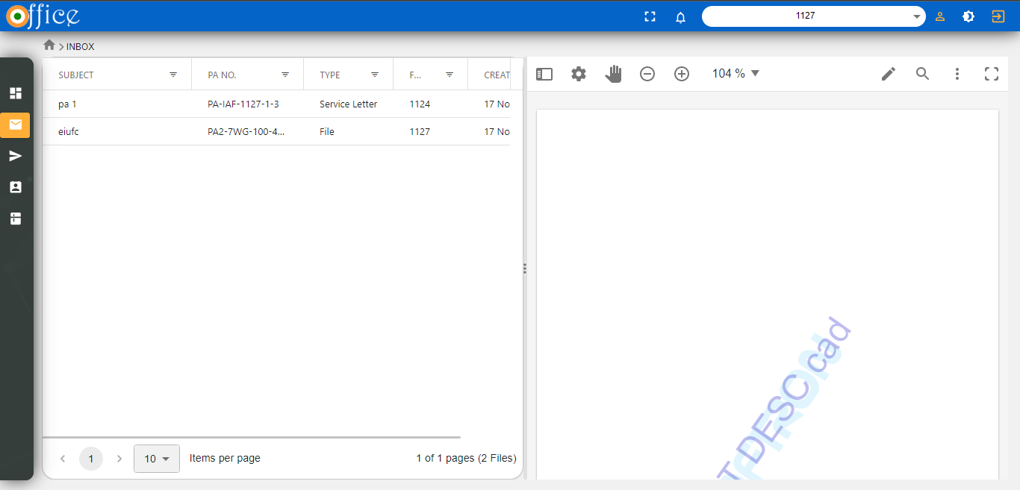

* After that Cord user will open the file and Create a Part Case. And to Create A partcase user will follow the Steps takes to Create a Partcase Earlier.
* The screen will open as Below to Create a Partcase.

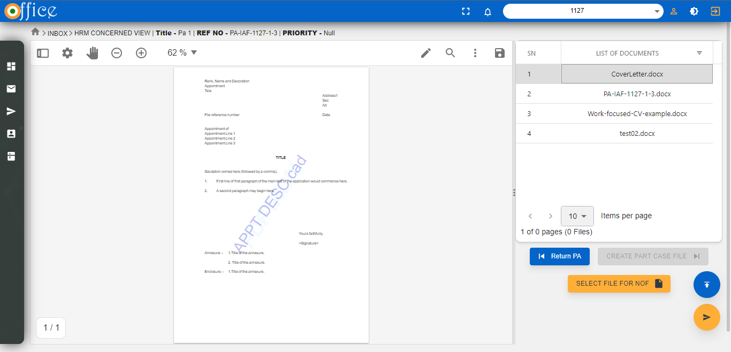

# MERGING THE PARTCASE

* If user wants to Merge the partcase which is created by Service Letter then he has to add a Cover Letter to return as a response to the user who has send Service Letter to Him.
* NOTE: If user wants to merge the partcase without adding the cover letter the it will give a POP-UP like the image given below.

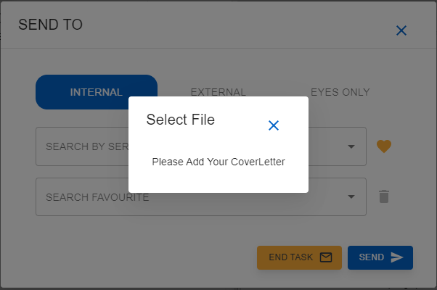

# STEPS TO MENTION DECISION ON THE PARTCASE FILE

* The user has to now take decision on the part case File.
* After creating the part case and adding Cover Note in the Part case a Dialogue Box will open as below. As king for the confirmation of File and selection of the Decision.
  + Select the File for Merging the Partcase.
  + Select the Decision The Cord User want to take on the File.
* Click on the **“SUBMIT”** button to Send the File to the USER who has send it as a Service Letter.

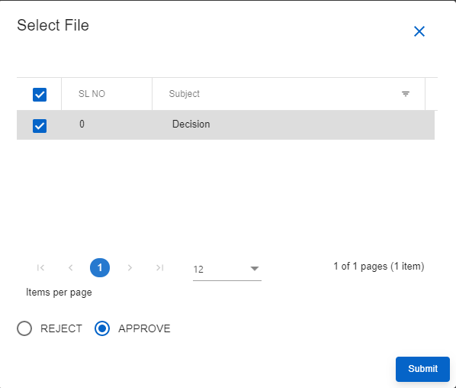

MERGE THE PARTCASE

# STEPS TO ADD PARTCASE BY THE USER

* When the user will receive the returned Service Letter on which decision has been made then he will ADD the service letter to the Partcase.

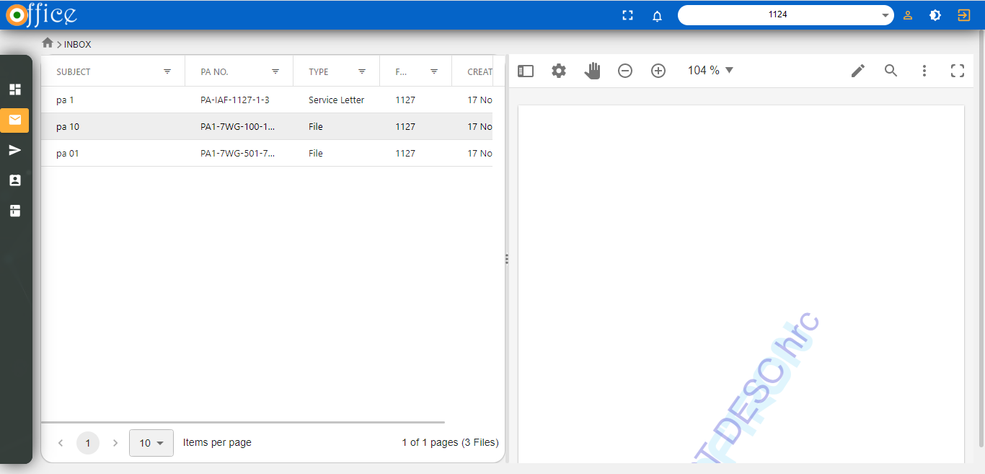

* When user will click on the Add to partcase Button As Shown in Below Image.

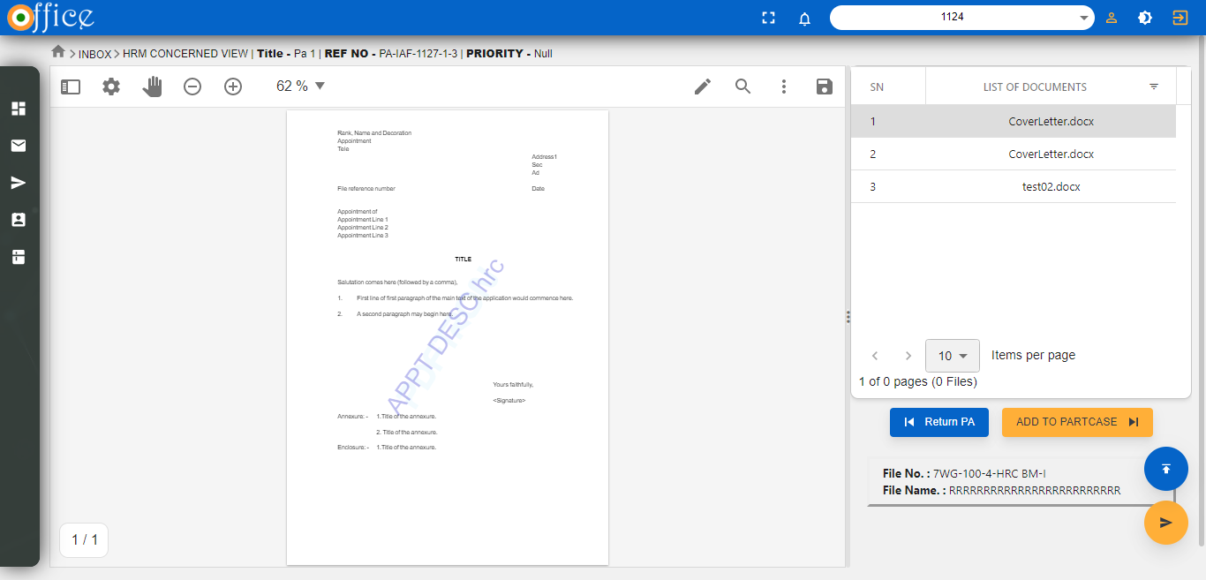

* After clicking on the “ADD TO PARTCASE ” button Following Confirmation Box will open To Confirm as he want to add Partcase or Not?

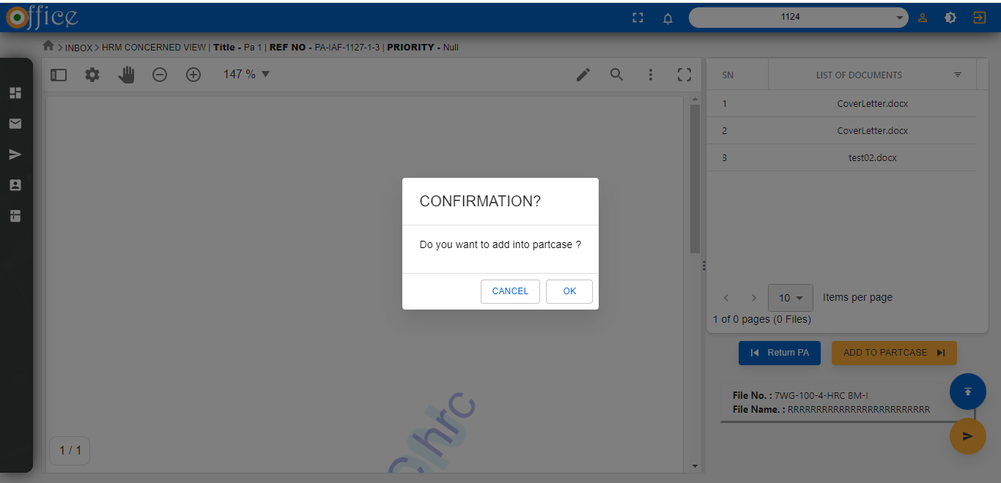

* After confirmation following split view will open in which the document of Service letter will Merge With the Partcase .
* User can confirm in the Enclosure Section.
* Image Below Shows the Same.

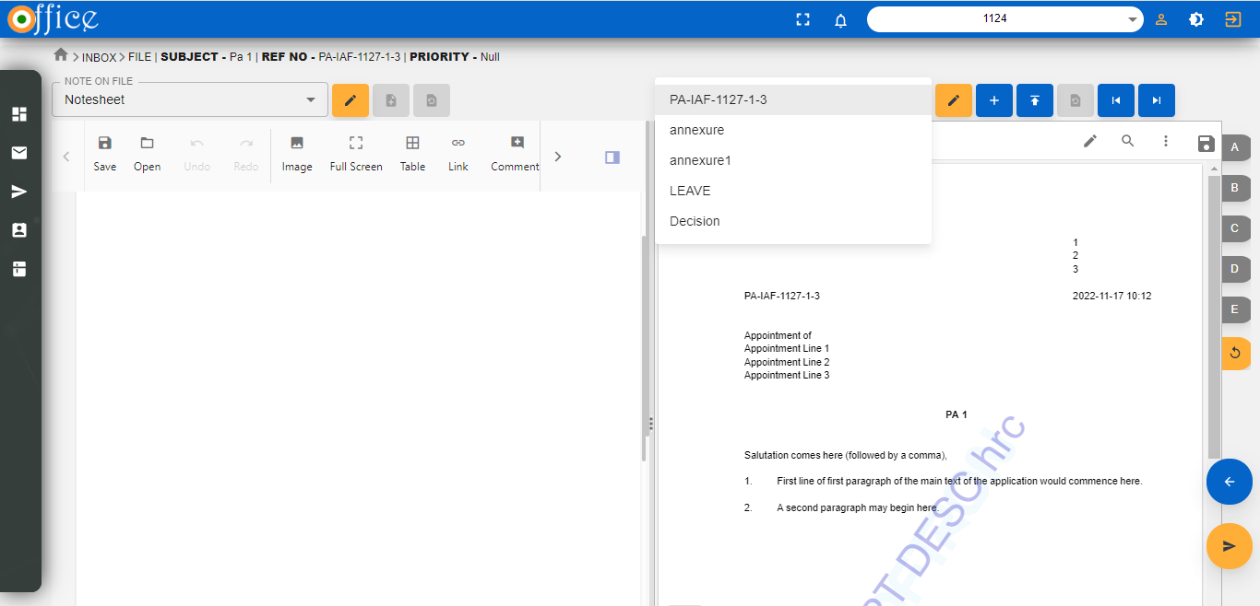

* Now User can merge his part case by clicking on “SEND” button .
* After clicking on “SEND” button Following pop-up will Open as Shown Below.

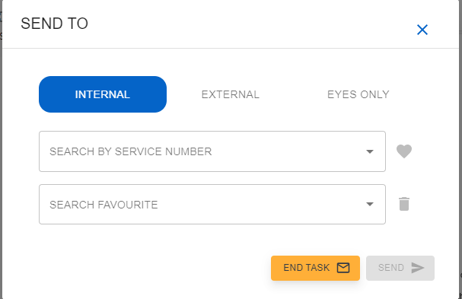

* Now user will Click on the End Task Button ,the following confirmation box will open as shown below.

NOTE: **Status will pe already filled as per decision taken on the service letter.**

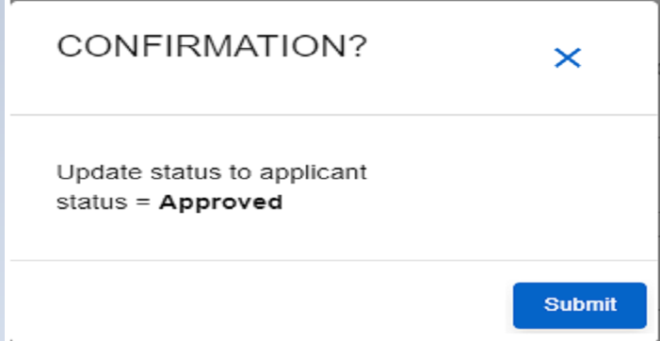

* **Now user will click on the SUBMIT button to complete the Work Flow.**